PARISH OF BLESSED SACRAMENT & BLESSED TRINITY (www.connahsquaycatholicchurch.org.uk)
Canon Joe Stewart: tel 01244 830358 / mobile 07550079995 / e-mail quayandferry@gmail.com
Convent – tel 01244 830692 / e-mail shoturs@yahoo.co.uk
23rd Sunday of Ordinary Time (A) 6th/7th September 2014

Sat 6th September 5.30pm @ CQ The Curry Family
Sun 7th September 9.30am @ QF Maxine Walker’s Intention
Sun 7th September 11.00am @ CQ People of the Parish

Mon 8th - 9.30am @ QF Feast The Nativity of the Blessed Virgin Mary Donor’s Intention
Tue 9th – 10.00am @ CQ Blessed Frederic Ozanam Donor’s Intention
Wed 10th - 9.45am @ CQ Novena to Our Lady
“ “ – 10.00am @ CQ Liturgy of the day Pietro Delucia RIP
Thu 11th - 9.30am @ QF St Deiniol, Bishop Donor’s Intention
Fri 12th - 10.00am @ CQ The Most Holy Name of Mary Donor’s Intention
Sat 13th - 9.30am @ QF St John Chrysostom Donor’s Intention
“ “ - 5.30pm @ CQ
Confessions - Saturday after 9.30am Mass @ QF & 5.00pm @ CQ

Church Cleaning Rota CQ
w/c Sep 7th – Moya, Paul & Lynda
w/c Sep 14th – Sharon, Jeanette & Sue
Sunday 11am Bidding Prayers Rota
Sep 7th – Rita / Sep 14th – tbc
Sep 21st – Claire / Sep 28th - tbc

Children’s Liturgy of the Word Rota
Sep 7th – Mrs Voas & Mrs Smith
Sep 14th – Mrs Doyle & Miss Doyle

Pax Christi: Join in solidarity to fast and pray for 1 hour or 24 hours, between 8th September & 7th October, to pray for peace in the world. Cf poster in porch and prayer cards.

Collections: this weekend (6th/7th Sept) there will be the retiring collections for The Poor Missions Fund – which was originally scheduled for 23rd/24th August. Next weekend (13th/14th Sept) will be the collection for the Church Maintenance Fund. Would parishioners in the Gift Aid scheme please use their special envelopes for this.

Knights of St Columba: As from 1st October, the 1st Council 614 2015 holy picture Calendars will be going on sale and will cost £3.50. All profits from the sales will be going towards the KSC national action project Mary's Meals, they will explain about Mary's Meals when they visit our church between Oct – Dec, but if you want to know more please visit www.marysmeals.org.uk. Also, if you would like to place your order beforehand, as there is a limited edition this year, please contact Bro Peter Carberry on 01352 750102 or e-mail pjcarberry@btinternet.com. Please try and support this worthy cause.

Food Bank: Thank you for generously bringing non-perishable food items to the churches. Many individuals are in need.

The Catholic Universe: Please remember that the Universe Catholic weekly is now available in our parish every week for a special price of only 50p (normally £1.30), with all monies going to help parish funds. Please do take a copy at the back of church and place your 50p in the box on the wall marked PAPERS.

Collection: Last weekend was £314.69 with a further £397.00 from the Gift Aid envelopes. This will give our parish an extra £99.25 we can claim back from tax paid. Please consider giving your offertory in a Gift Aid envelope if you pay tax. The amount raised for the Cafod Gaza/Iraq appeal was £394.00 and the Xaverian Mission Appeal came to £414.73.

Items for the bulletin: to Carmel Smith, tel 01244 830985 or e-mail carmel_smith@sky.com by Weds evening please.

Pope Francis has a special General and a Missionary Intention each month. We’re invited to pray with him. SEPTEMBER: General-That the mentally disabled may receive the love and help they need for a dignified life.
Missionary-That Christians, inspired by the Word of God, may serve the poor and suffering.
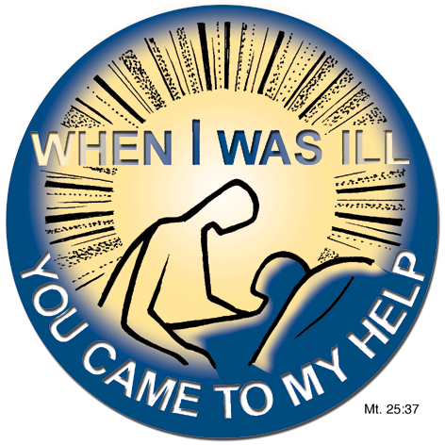
Pray
With
Pope Francis

