PARISH OF BLESSED SACRAMENT & BLESSED TRINITY (www.connahsquaycatholicchurch.org.uk)
Canon Joe Stewart: tel 01244 830358 / mobile 07550079995 / e-mail quayandferry@gmail.com
Convent – tel 01244 830692 / e-mail shoturs@yahoo.co.uk
1st Sunday of Advent (B) 29th/30th December 2014

Sat 29th November 5.30pm @ CQ Alan Walmsley Thanksgiving
Sun 30th November 9.30am @ QF 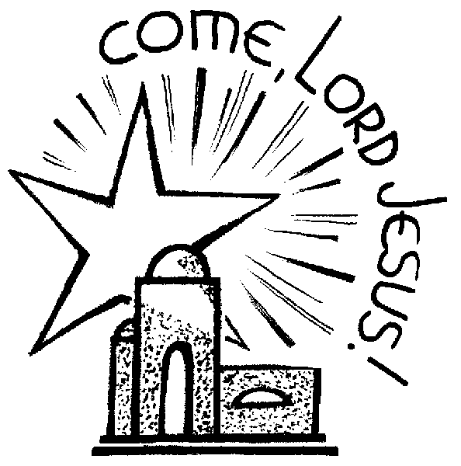 Cyril & Peggy Hallett RIP
Sun 30th November 11.00am @ CQ People of the Parish

on 1st - 9.30am @ QF Liturgy of the day Wallace & Muriel Stephenson RIP
Tue 2nd – 10.00am @ QF Requiem Mass for Ada Futia RIP
Wed 3rd - 9.45am @ CQ Novena to Our Lady
“ “ – 10.00am @ CQ St Francis Xavier Holy Souls
Thu 4th - 9.30am @ QF Liturgy of the day Julie Owen (sick)
Fri 5th - 10.00am @ CQ Liturgy of the day Intentions of Marie Worden & Marie Rodden
Sat 6th - 9.30am @ QF St. Nicholas Holy Souls
“ “ - 5.30pm @ CQ Beryl Park (sick)
Confessions - Saturday after 9.30am Mass @ QF & 5.00pm @ CQ

Church Cleaning Rota CQ
w/c Nov 30th – Moya, Paul & Lynda
w/c Dec 7th – Sharon, Jeanette & Sue
Children’s Liturgy of the Word Rota
Nov 30th – Mrs Burns & Miss Murdoch
Dec 7th – Miss Murdoch & Mrs Burns
Sunday 11am Bidding Prayers Rota
2nd Readers will read the Bidding Prayers

Please pray: for the repose of the soul of Ada Futia who passed away 22nd November. Remember her family in your prayers.

Thank-you: A big thank you for all your support- both on the day, by donating items, and helping on the stalls; we had a marvellous response. The result of the Christmas Fayre raffle will be on the notice board.

Grand Christmas draw Sunday 14th December in the parish flat after 11 am Mass. Please return sold tickets. (extra tickets still available). If you can donate one item for the Christmas hamper put your name on sheet.
Please look at notice board in the porch, we still need contributions for £2 squares(this money goes towards prizes for our main raffle)
SVP Christmas Gifts: the tree will be in the porch for the next two weeks, please take a tag, buy a present up to the value of £10, then return the present with the same tag on it no later than the weekend of 13th/14th December.

SVP Annual Collection: at all Masses next weekend (6th/7th December). This is the only collection SVP have, so please try to be generous.

First Communion: there will be a meeting for parents on Thurs 4th December, 5.30pm at Venerable Edward Morgan School. If you are unable to attend please see Canon Stewart ASAP to enrol your child. Canon Stewart expects enrolled children and parents to attend Mass regularly.

Group Nativity: the next meeting will on 7th December after 11am Mass in the Presbytery.

Light Up a Life Service: for Nightingale House Hospice, at St Andrews Methodist Church, Connah’s Quay on Sunday 7th December @ 6pm.

Christmas Draw tickets: please return them no later than 7th December.
Medjugorje Irish Centre: celebrating 10 yrs. Win 7 nights apartment accommodation in Medjugorje for 4 people staying in their 4 star Apart Hotel. Text Pilgrim, See details at www.med-irishcentre.com or call 028 82241 888
Collection: Last weekend was £297.69 with a further £528.50 from the Gift Aid envelopes. The retiring collection for the Church Maintenance Fund amounted to £387.43 of which £218.50 was Gift Aided. This will give our parish an extra £186.75 we can claim back from tax paid. Please consider giving your offertory in a Gift Aid envelope if you pay tax.

Looking ahead: the next Polish Masses - 13th & 20th December.

Items for the bulletin: to Carmel Smith, tel 01244 830985 or e-mail carmel_smith@sky.com by Weds evening please.
Christmas Mass Times
24th December – Children’s Mass at CQ @ 5.30 pm and Midnight Mass at CQ.
25th December – 9.30am at QF and 11.00am at CQ

