PARISH OF BLESSED SACRAMENT & BLESSED TRINITY

www.connahsquaycatholicchurch.org.uk www.fb.me/deesidecatholic
Canon Joe Stewart: tel 01244 830358 / mobile 07550079995 / email priestcquay@rcdwxm.org.uk
Corpus Christi (A) 14th June 2020
Wrexham Diocese Charity Number 700426

+

Canon Joe will say Mass each day for the following intentions:-

Sun 14th June Corpus Christi People of the Parish
Mon 15th June Liturgy of the Day Baby Lewis and Family
Tue 16th June Liturgy of the Day Glyn Hughes RIP
Wed 17th June Liturgy of the Day Mary Kelly
Thu 18th June Liturgy of the Day Alan Walmsley RIP
Fri 19th June The Most Sacred Heart of Jesus Maria Devine RIP
Sat 20th June The Immaculate Heart of Mary Moira Catherall RIP
Sun 21st June 12th Sunday in Ordinary Time People of the Parish

CHURCHES ARE CLOSED TO ALL ACTS OF WORSHIP UNTIL FURTHER NOTICE
by order of the Bishops’ Conference of England and Wales (www.cbcew.org.uk)

If any parishioner would like a copy of the bulletin emailed to them, please email Canon Joe on the parish email address to give permission. This is to comply with GDPR regulations.

Our parish now has a Facebook page – if you are on FB come and like the page and join us on www.fb.me/deesidecatholic - share your posts and photos there and invite your friends

The Diocese of Wrexham (www.rcdwxm.org.uk) have a Facebook page - https://www.facebook.com/wrexhamdiocese/ with links to their YouTube channel - where you can follow Bishop Peter live streaming Mass and other services, and also access videos of Mass

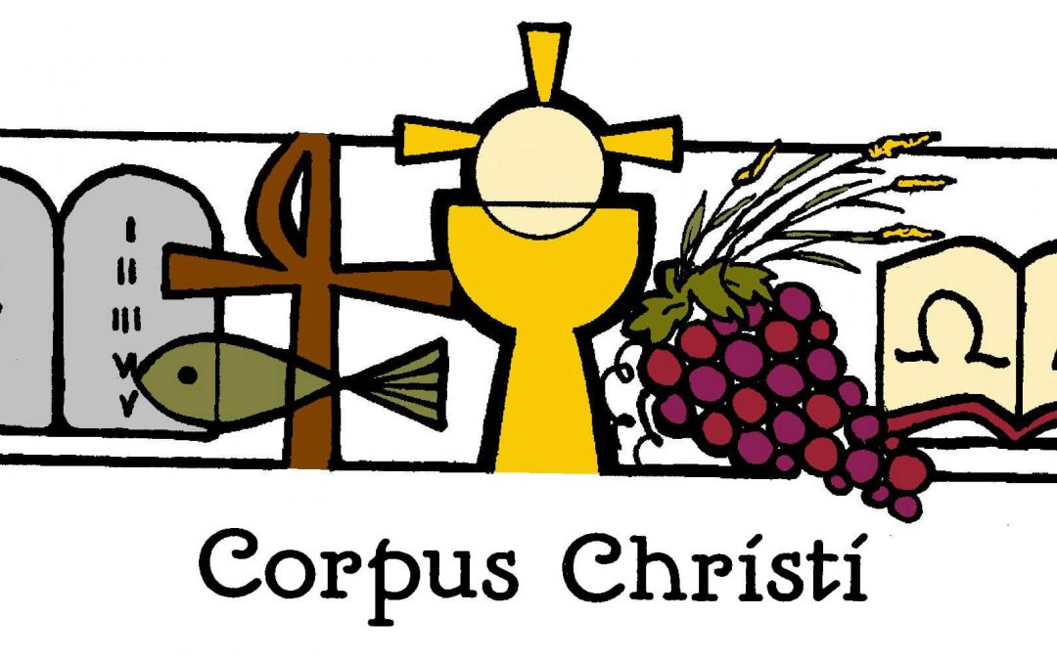

Please Pray For:-
- Glyn Hughes from Connah’s Quay, who died on May 30th. His funeral is at Connah’s Quay Cemetery on June 16th, close family only. May he Rest In Peace. We pray also for his wife Susan and his family.
- Baby Lewis, grandson of Pat and Les Thornton, who was born prematurely and is still poorly, and his parents.

Matthew Bond is soon to be ordained to the diaconate. Bishop Peter asks us to pray for him, and also, if anyone has concerns over the ordination, to email him on pa@rcdwxm.org.uk

Canon Joe sends his best wishes - he is still well but self-isolating, and he remembers all of us in his prayers and daily Masses, and is praying for a swift and safe end to our current lockdown.

Private Prayer – it is likely that Churches may be able to open for private prayer only by the end of the month. We will have to look at how best to clean and sanitise the Church between visits. Canon will provide all the necessary supplies to ensure everyone is safeguarded.

First Holy Communion, Getting To Know You Sessions, PAC Meeting and SVP Meetings are all cancelled until further notice.

Collections for Church Funds: Our Churches’ expenses are still continuing during this Coronavirus crisis – Canon Joe would be very grateful if people could continue donating and putting the money to one side or in their Gift Aid envelopes.
You may wish to set up a Standing Order to give your donations regularly – please contact Canon Joe for bank details.

Items for the bulletin: to Ann Payton by Weds evening please, tel 01244 821010 or e-mail ann.dragonden@btinternet.com

