PARISH OF BLESSED SACRAMENT & BLESSED TRINITY

www.connahsquaycatholicchurch.org.uk www.fb.me/deesidecatholic
Canon Joe Stewart: tel 01244 830358 / mobile 07550079995 / email priestcquay@rcdwxm.org.uk
12th Sunday in Ordinary Time (A) 21st June 2020
Wrexham Diocese Charity Number 700426

+

Canon Joe will say Mass each day for the following intentions:-

Sun 21st June 12th Sunday in Ordinary Time People of the Parish
Mon 22nd June Sts John Fisher & Thomas More, Martyrs Patrick Ward RIP
Tue 23rd June Liturgy of the Day Teresa Matthews RIP
Wed 24th June The Birth of St John the Baptist Tom Philips RIP
Thu 25th June Liturgy of the Day Baby Lewis
Fri 26th June Liturgy of the Day Canon Stewart’s Intention
Sat 27th June Liturgy of the Day Tom & Janet Matthews’ Intention
Sun 28th June Sts Peter and Paul, Apostles People of the Parish

CHURCH MAY SOON BE OPEN FOR PRIVATE PRAYER ONLY – further details below

If any parishioner would like a copy of the bulletin emailed to them, please email Canon Joe on the parish email address to give permission. This is to comply with GDPR regulations.

Our parish now has a Facebook page – if you are on FB come and like the page and join us on www.fb.me/deesidecatholic - share your posts and photos there and invite your friends

The Diocese of Wrexham (www.rcdwxm.org.uk) have a Facebook page - https://www.facebook.com/wrexhamdiocese/ with links to their YouTube channel - where you can follow Bishop Peter live streaming Mass and other services, and also access videos of Mass

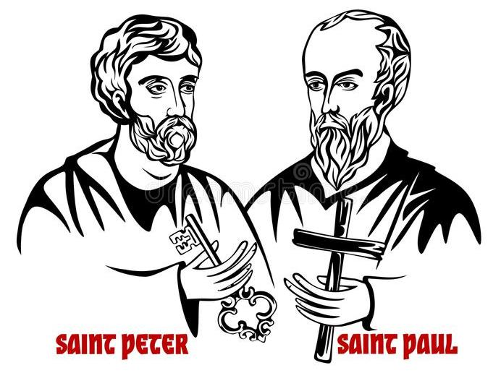

Please Pray For:-
- Baby Lewis, grandson of Pat and Les Thornton, who was born prematurely and is still poorly, and his parents.
- Marie Curry, who died recently, and her family. The family were in our parish for over 50 yrs.

Canon Joe sends his best wishes - he is still well but self-isolating, and he remembers all of us in his prayers and daily Masses, and is praying for a swift and safe end to our current lockdown.

Congratulations to Canon Joe on his 36th Priestly Anniversary on Friday June 26th. May the good Lord strengthen him to continue the work He has entrusted to him.

Private Prayer – although First minister Mark Drakeford has said churches may open from Monday 22nd, the Diocese has said that churches intending to open must :-
1. Inform the Bishop of their request
2. Confirm all requirements are in place and risk assessment complete. A check list will be issued ASAP.
3. Await an inspection visit to satisfy the Diocese with regard to the precautions and risk assessment
4. Be issued with the certificate for re-opening

First Holy Communion, Getting To Know You Sessions, PAC Meeting and SVP Meetings are all cancelled until further notice.

Collections for Church Funds: Our Churches’ expenses are still continuing during this Coronavirus crisis – Canon Joe would be very grateful if people could continue donating and putting the money to one side or in their Gift Aid envelopes.
You may wish to set up a Standing Order to give your donations regularly – please contact Canon Joe for bank details.

Items for the bulletin: to Ann Payton by Weds evening please, tel 01244 821010 or e-mail ann.dragonden@btinternet.com

