BLESSED SACRAMENT & BLESSED TRINITY CHURCHES (www.connahsquaycatholicchurch.org.uk)
Canon Joe Stewart: tel 01244 830358 / mobile 07550079995 / e-mail quayandferry@gmail.com
Convent – tel 01244 830692 / e-mail Shoturs@aol.com
EASTER SUNDAY of the Resurrection of the Lord 20 April 2014

Sun 20th April 9.30am @ QF Dr Michael Gavin Jnr RIP
Sun 20th April 11.00am @ CQ People of the Parish

Mon 21st - 9.30am @ QF Monday of the Octave of Easter Sr Alison Marjoribanks (Golden Jubilee)
Wed 23rd. 9.45am @ CQ Novena to Our Lady
No Mass in either church Tuesday until Saturday 5.30pm

Sat 26th – 5.30pm @ CQ Saturday of the Octave of Easter Ann Marshall RIP
Confessions - 5.00pm @ CQ

Sunday 11am Bidding Prayers Rota
Apr 20th – Claire
Apr 27th - Rita / May 4th – Jess
Children’s Liturgy of the Word Rota
Apr 20th – No Children’s Liturgy Today
Apr 27th – Angela and Linda
Church Cleaning Rota CQ
w/c Apr 20th – Moya & Paul

A very happy Easter
To
Each one
Alleluia!
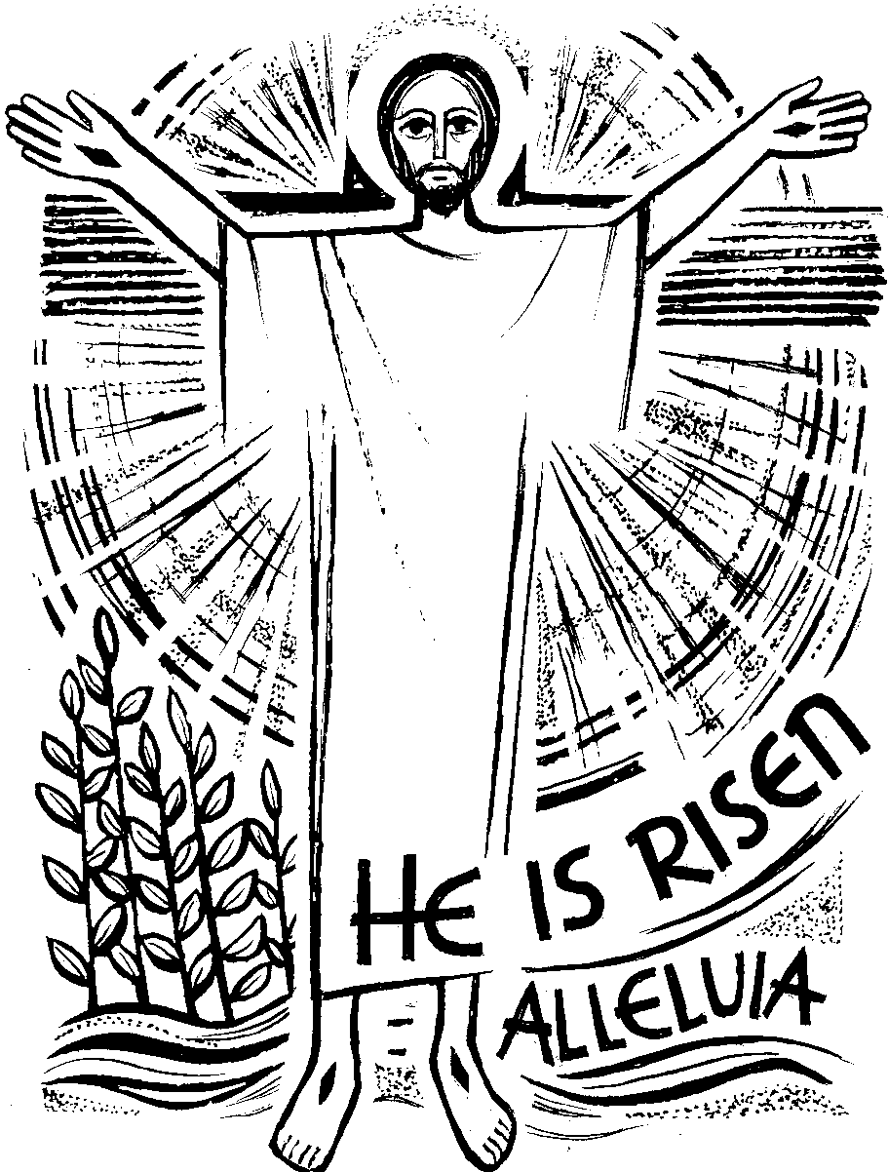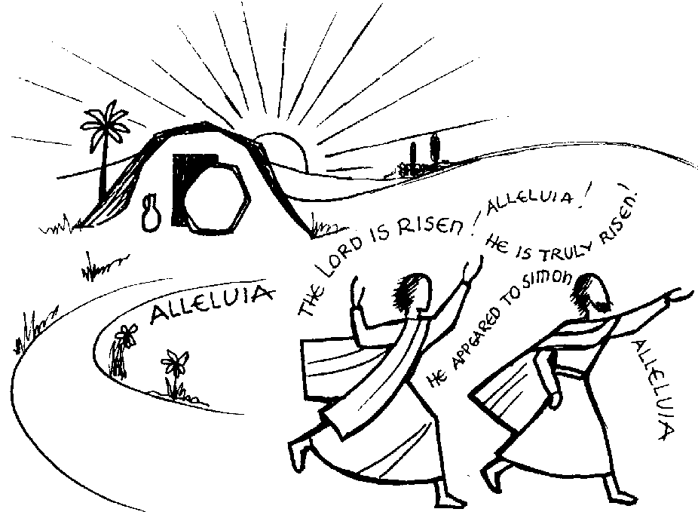

Canon Joe thanks everyone for contributing to the beauty and prayerfulness of the liturgy in Holy Week. Thank you especially to the altar servers, the Readers and Musicians, those who cleaned the church and those who arranged the flowers.

Collection : Last weekend was £317.26 with a further £454.00 from the Gift Aid envelopes. This will give our parish an extra £113.50 we can claim back from tax paid. Please consider giving your offertory in a Gift Aid envelope if you pay tax.

Looking Ahead: Fri 16th May: Race Night for Cafod in The Groves Community Club, Shotton. There's an opportunity now to buy a horse for one of the races for £2 - or sponsor a race for £10. (See Sr. Vianney)
Sat 17th May – Polish Mass @ 7.00pm
Mon 19th May: Emeritus Bishop Edwin will speak on his Pilgrimage to Compostella at the AGM of Churches Together/Deeside Cytun at 7pm in Quaystone (alongside Wepre Post Office). Everyone welcome.

Items for the bulletin: to Carmel Smith, tel.01244 830985 or e-mail carmel_smith@sky.com by Weds evening please.

First Holy Communion 2014 -These are the children making their First Communion in June:-
Isobel Weigh Gracie Mitchell Jack Hannam Erika Yedrzejczak Evan Jones Luke Farren
Esme Primrose Michaela Hart Nia Griffiths Sebastian James Liam Sanderson
Ellie Condron Martyna Cecot Mateusz Marek Sacewicz

Please remember these children and their families in your prayers.

